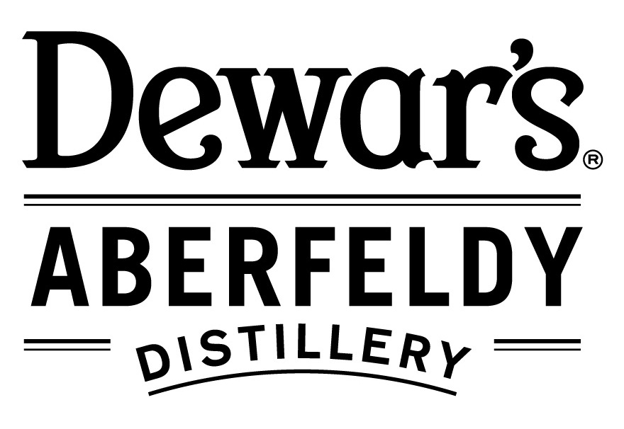
Palme-Dewar Short Film Competition 2017

Registration form

- Registration by Saturday 30th September 2017
- Entry fee £10 per film
- Submission of film(s) by Saturday 14th October 2017
- Competition event Saturday 18th November 2017

Name:
Postal address:

E-mail address:
Contact telephone number:
Number of films being entered:
- Films must have been completed between 2015 and 2017
- Each film entry should be no more than 10 minutes in length
 | Film Title | Director / Producer | Run time (mins)
1
2
3

Please complete the registration form and return by 30 September 2017:
- By post to | Palme-Dewar Competition, Heartland Film Society,  The Locus Centre, The Square, Aberfeldy PH15 2DD
- OR by email to | oscar@heartlandfilmsociety.org.uk

Please send the entry fee of £10 per film when registering:
- By cheque | Payable to ‘Heartland Film Society’  - Include the registration form with your cheque and post to the above address
- OR by BACS | Payable to  Bank of Scotland, Aberfeldy Branch 80-05-22, Account 00412884  - Include surname, initial and ref: PD17 with the BACS payment and send the registration form separately  - If paying by this method, enter details in the box below  BACS

Please submit your film(s) by 14th October 2017:
- By post | I film per DVD / Blu-ray disc to the above address  - Ensure your film(s) can be viewed with Windows Media Player and/or Apple Quicktime
- OR online | Upload your film(s) to Vimeo or other online screener  - Ensure privacy settings allow access by Heartland Film Society  - Include web link and password here or email the information separately to the email address above  Web link:  Password:

- Acceptable formats | iMovie, .mp4, .mov  - If you cannot provide your film in one of these formats or have any other questions, please contact us at the email address above.
- Copyright | - By registering and submitting the named film(s) to the competition, you confirm that you have the right to do so and that copyright has been acquired as appropriate for all film content.
- Film screening | - On our part, Heartland Film Society (HFS) confirms that submitted film(s) will not be screened outwith the competition event, except by prior arrangement with the film owner(s).  - Short-listed films will be provided by HFS to Dewars Aberfeldy Distillery for screening at the competition event.  - Winning film-makers will be invited to participate in a screening of their film at a later date, at the Birks Cinema, Aberfeldy.
Your signature:
Heartland Film Society: www.heartlandfilmsociety.org.uk
Palme-Dewar competition: http://www.palme-dewar.co.uk

